REINFORCEMENT LEARNING
2. Bandit problems and online learning:
An n-Armed Bandit Problem, Action-Value Methods Tracking a Nonstationary Problem, Optimistic Initial Values Upper-Confidence-Bound Action Selection Gradient Bandits
PAST QUESTIONS:
- You are playing a slot machine with three arms. Each time you pull an arm, you either win $1 or lose $1 with equal probability. You decide to randomly choose an arm to pull each time. If you play the slot machine 100 times, how much money do you expect to win or lose on average? (M24)
- Explain the exploration-exploitation trade-off and its significance in reinforcement learning. (M24)
- What are the advantages and disadvantages of action-value methods compared to other reinforcement learning techniques? (M24)
- Explain exploration approach and exploitation approach in multi armed bandit problem? (M25)
- Write gradient bandit algorithm and explain its steps? (M25)
- After 12 iterations of the UCB 1 algorithm applied on a 4-arm bandit problem, we have n 1=3, n2=4, n3=3, n4=2 and Q12(1)=0.55, Q12(2)=0.63, Q12(3)=0.61, Q12(4)=0.40. Which arm should be played next?
NOTES:

*Exploration & Exploitation trade-offs :-
Exploration in reinforcement learning is the process where an agent takes uncertain or random actions to gather new information about its environment, rather than just exploiting known rewards. It is essential for discovering optimal policies, avoiding sub-optimal local minima, and solving sparse-reward problems.
Exploration is trying new possibilities in order to find better rewards.

Exploitation in reinforcement learning (RL) is the strategy of using an agent's current knowledge to make decisions that maximize expected rewards. Instead of seeking new information, the agent acts "greedily" to choose the best-known actions based on prior experience, ensuring high immediate returns but risking sub-optimal long-term policies.
Exploitation is to keep opting for same actions that has given some significant rewards in the past.

The exploration-exploitation trade-off in reinforcement learning (RL) is the dilemma of balancing gathering new information about an environment (exploration) with maximizing rewards using current knowledge (exploitation). Effective RL requires balancing this, as over-exploration wastes time, while over-exploitation leads to suboptimal, locally optimal policies.
Keys -
- Exploration: Taking random or novel actions to discover information about the environment, aiming for higher long-term rewards.
- Exploitation: Choosing the best-known action based on current knowledge to maximize immediate rewards.
- The Dilemma: An agent must decide whether to try an uncertain action that might be better or stick with a known action that works well.
Strategies for Balancing -
- Epsilon-Greedy: The agent chooses a random action with probability (epsilon) (exploration) and the best action with probability (1-epsilon) (exploitation). Typically, epsilon decreases over time, shifting from exploration to exploitation as the agent learns.
- Upper Confidence Bound (UCB): The agent picks actions that have the highest potential reward based on uncertainty, preferring actions with high uncertainty to encourage exploration.

*Action-Value methods :-
Action-value methods are reinforcement learning techniques that estimate the value of taking a particular action in a given state. This value is represented by the action-value function, denoted as $Q(s,a)$, which gives the expected cumulative reward obtained by taking action $a$in state $s$and following a particular policy thereafter.
These methods are widely used in algorithms such as Q-Learning, SARSA, and Expected SARSA.
Action-Value Function
The action-value function is defined as:
$$Q(s,a)=E[R_{t}∣s_{t}=s, a_{t}=a]$$
$$Q(s,a)=E[R_{t}∣s_{t}=s, a_{t}=a]$$
Where:
- $Q(s,a)$: Expected reward for taking action $a$in state $s$
- $R_{t}$: Reward received
- $E$: Expected value
Advantages of Action-Value Methods –
1. Simple and Easy to Understand
Action-value methods are conceptually straightforward. The agent learns a numerical value for each state-action pair and chooses actions with the highest values.
2. Model-Free Learning
They do not require knowledge of the environment's transition probabilities or reward model. The agent learns directly from interaction.
3. Suitable for Online Learning
The value estimates are updated incrementally after each step, making them suitable for real-time applications.
4. Balances Exploration and Exploitation
Action-value methods can be combined with strategies such as:
- ε-Greedy
- Softmax
- Upper Confidence Bound (UCB)
5. Proven Convergence
Algorithms like Q-Learning converge to the optimal policy under suitable conditions.
6. Computationally Efficient for Small Problems
For problems with limited state and action spaces, tabular action-value methods are fast and memory efficient.
7. Foundation for Deep Reinforcement Learning
Modern methods like Deep Q-Networks (DQN) are built upon action-value estimation.
Disadvantages of Action-Value Methods –
1. Poor Scalability
For large or continuous state spaces, storing $Q(s,a)$for all state-action pairs becomes impractical.
2. Slow Learning in Large Environments
The agent may need many interactions to visit enough states and actions.
3. Requires Explicit Exploration
Without a proper exploration strategy, the agent may converge to suboptimal policies.
4. Difficulty with Continuous Actions
Standard action-value methods are not directly suitable when the action space is continuous.
5. Sensitive to Hyperparameters
Performance depends heavily on:
- Learning rate $α$
- Discount factor $γ$
- Exploration rate $ϵ$
6. Overestimation Bias
Methods such as Q-Learning may overestimate action values due to the maximization step.
7. Less Effective in Highly Stochastic Environments
Policy-gradient methods often perform better when the environment is very noisy or continuous.

*Upper-Confidence-Bound :-
The Upper Confidence Bound (UCB) algorithm is a strategy used in Reinforcement Learning, particularly in the Multi-Armed Bandit (MAB) problem, to balance the trade-off between:
- Exploration: Trying less-selected actions to gather more information.
- Exploitation: Choosing the action with the highest estimated reward.
UCB selects actions based on both the average reward and the uncertainty associated with each action.
Upper-Confidence Bound action selection uses uncertainty in the action-value estimates for balancing exploration and exploitation.
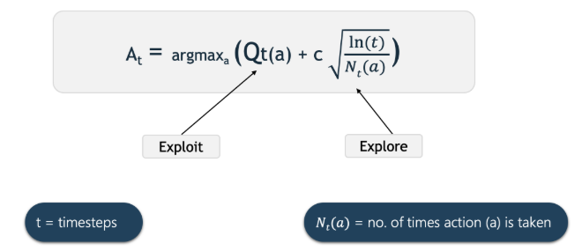

*Gradient Bandits :-
The Gradient Bandit Algorithm is a reinforcement learning technique that learns numerical preferences H_t(a) for each action a rather than estimating action values (Q-values). It uses stochastic gradient ascent to update preferences, employing a softmax function to convert these preferences into action probabilities, increasing the likelihood of high-reward actions.
Instead of always selecting the action with the highest estimated reward (as in greedy methods), it treats action selection as a probability distribution and typically uses the Softmax (Gibbs) distribution to decide which action to choose.
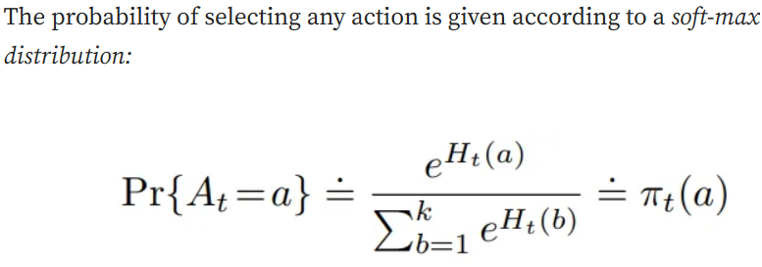
Algorithm Steps –
The algorithm proceeds iteratively through the following steps:
1. Initialize Preferences
Set the initial preferences for all actions to zero:
$$H_{1}(a)=0\text{for all actions }a$$
2. Calculate Action Probabilities
At each time step $t$, convert the preferences into a probability distribution using the Softmax function:
$$π_{t}(a)=\frac{e^{H_{t}(a)}}{\sum_{b=1}^{k}{e^{H_{t}(b)}}}$$
$$π_{t}(a)=\frac{e^{H_{t}(a)}}{\sum_{b=1}^{k}{e^{H_{t}(b)}}}$$
Where:
- $π_{t}(a)$: Probability of selecting action $a$
- $H_{t}(a)$: Preference of action $a$
- $k$: Total number of actions
3. Select and Execute Action
Choose an action $A_{t}$according to the probabilities $π_{t}(a)$, and observe the reward $R_{t}$.
4. Update Reward Baseline
Compute or update the average reward ${\overset{ˉ}{R}}_{t}$(baseline).
- This is the average of all rewards received up to time $t$.
- The baseline helps reduce variance and speeds up learning.
5. Update Preferences
Update the preference for the selected action and all other actions using stochastic gradient ascent.
(a) For the Selected Action $A_{t}$
$$H_{t+1}(A_{t})=H_{t}(A_{t})+α(R_{t}-{\overset{ˉ}{R}}_{t})(1-π_{t}(A_{t}))$$
(b) For All Other Actions $a≠A_{t}$
$$H_{t+1}(a)=H_{t}(a)-α(R_{t}-{\overset{ˉ}{R}}_{t})π_{t}(a)$$
$$H_{t+1}(A_{t})=H_{t}(A_{t})+α(R_{t}-{\overset{ˉ}{R}}_{t})(1-π_{t}(A_{t}))$$
Interpretation:
- If the received reward $R_{t}$is higher than the average reward ${\overset{ˉ}{R}}_{t}$, the preference for the selected action increases.
- If the reward is lower than average, its preference decreases.
- Preferences of non-selected actions are adjusted in the opposite direction.

